1.Sfera jednostkowa

def make_X_Y_Z_sphere():  
 s = np.linspace(0, 2 * np.pi, 100)  
 t = np.linspace(0, np.pi, 100)  
  
 x = np.outer(np.cos(s), np.sin(t))  
 y = np.outer(np.sin(s), np.sin(t))  
 z = np.outer(np.ones(np.size(s)), np.cos(t))  
 return x, y, z

def draw_3d(x, y, z, viev_elev=20, view_azim=30):  
 fig = plt.figure(figsize=(15, 10))  
 ax = fig.add_subplot(111, projection='3d')  
 ax.view_init(elev=viev_elev, azim=view_azim)  
 ax.plot_surface(x, y, z, rstride=4, cstride=4, color='r', alpha = 0.3)  
 ax.set_xlabel('X')  
 ax.set_ylabel('Y')  
 ax.set_zlabel('Z')  
 plt.show()

def draw_sphere():  
 x, y, z = make_X_Y_Z_sphere()  
 draw_3d(x, y, z)

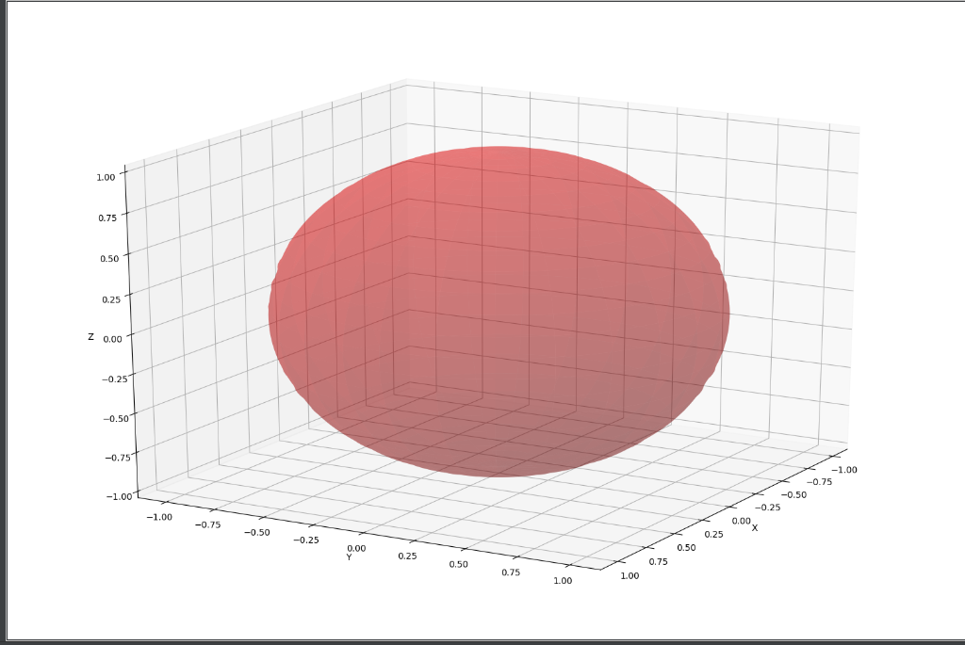

2)EMacierz przekształcające sferę w elipsoidy

def transform_vectors():  
 A1 = [[1, 0.02, 0.3], [0.02, 0.45, 1.43], [0.01, 0.03, 0.45]]  
 A2 = [[0.5, -3.2, 0.3], [1.4, 1.2, -0.40], [0.7, -1.8, 0.65]]  
 A3 = [[-2.3, 0.15, -2], [0.12, -0.45, 1], [1, -0.6, -1.2]]  
 return A1, A2, A3

def make_X_Y_Z_elipse(A):  
 s = np.linspace(0, 2 * np.pi, 100)  
 t = np.linspace(0, np.pi, 100)  
  
 x = np.outer(A[0][0] * np.cos(s), np.sin(t)) +\  
 np.outer(A[0][1] * np.sin(s), np.sin(t)) +\  
 np.outer(A[0][2] * np.ones(np.size(s)), np.cos(t))  
  
 y = np.outer(A[1][0] * np.cos(s), np.sin(t)) + \  
 np.outer(A[1][1] * np.sin(s), np.sin(t)) + \  
 np.outer(A[1][2] * np.ones(np.size(s)), np.cos(t))  
  
 z = np.outer(A[2][0] * np.cos(s), np.sin(t)) + \  
 np.outer(A[2][1] * np.sin(s), np.sin(t)) + \  
 np.outer(A[2][2] * np.ones(np.size(s)), np.cos(t))  
  
 return x, y, z

def draw_elipse(A):  
 x, y, z = make_X_Y_Z_elipse(A)  
 draw_3d(x, y, z)

def draw_3_elipse():  
 A1, A2, A3 = transform_vectors()  
 draw_elipse(A1)  
 draw_elipse(A2)  
 draw_elipse(A3)

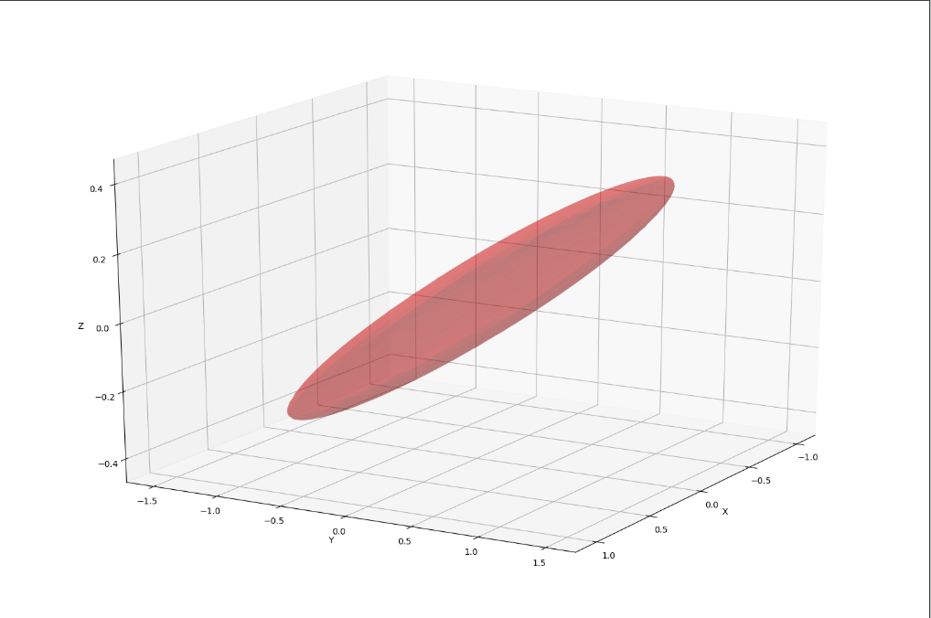

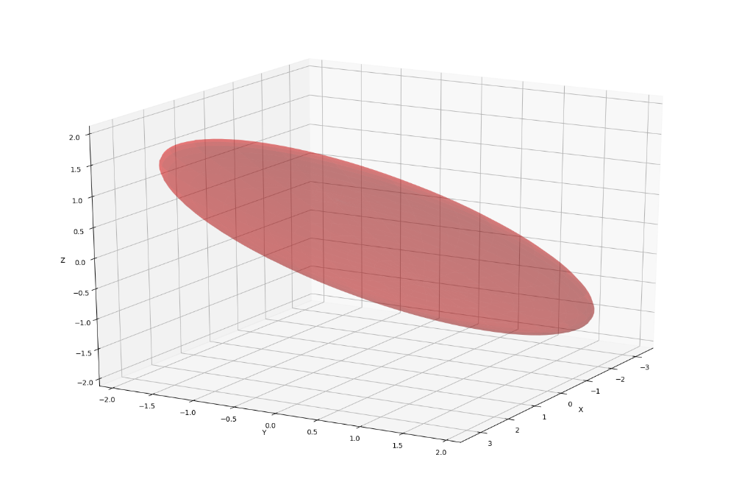

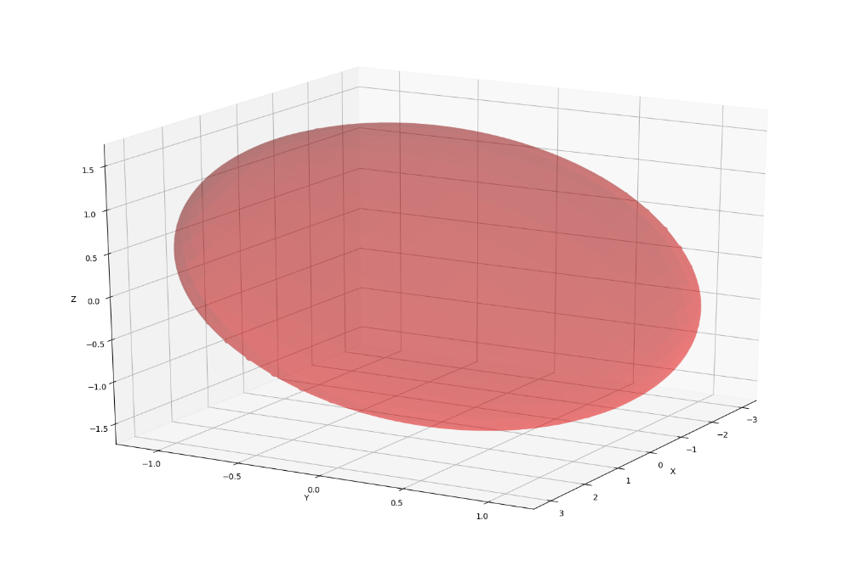

3. Rozkład według wartości osobliwych (SVD) i wizualizacja półosi wyznaczonych za pomocą SVD.

def draw_3d_with_singular_values(x, y, z, A):  
 fig = plt.figure(figsize=(15, 10))  
 ax = fig.add_subplot(111, projection='3d')  
 ax.plot_surface(x, y, z, rstride=4, cstride=4, color='r', alpha=0.3)  
  
 #draw singular values  
 U, S, VT = np.linalg.svd(A)  
 diag_S = np.diag(S)  
  
 for row in diag_S:  
 vector = np.dot(U, row)  
 ax.plot([0, vector[0]], [0, vector[1]], [0, vector[2]], linewidth=5)  
  
 ax.set_xlabel('X')  
 ax.set_ylabel('Y')  
 ax.set_zlabel('Z')  
 plt.show()

def draw_elipse_with_singular_values(A):  
 x, y, z = make_X_Y_Z_elipse(A)  
 draw_3d_with_singular_values(x, y, z, A)

def draw_3_elipse_with_singular_values():  
 A1, A2, A3 = transform_vectors()  
 draw_elipse_with_singular_values(A1)  
 draw_elipse_with_singular_values(A2)  
 draw_elipse_with_singular_values(A3)

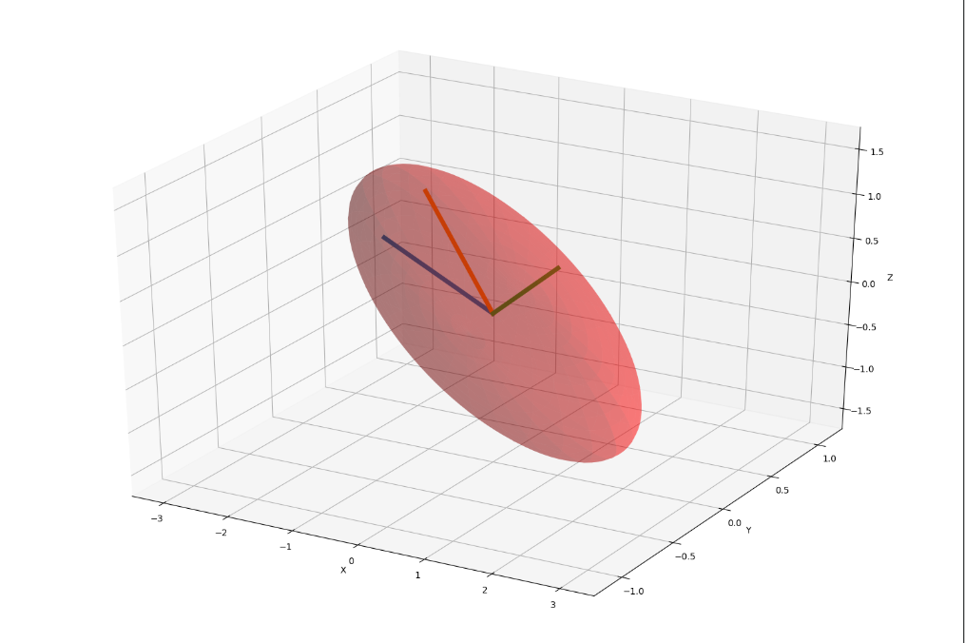

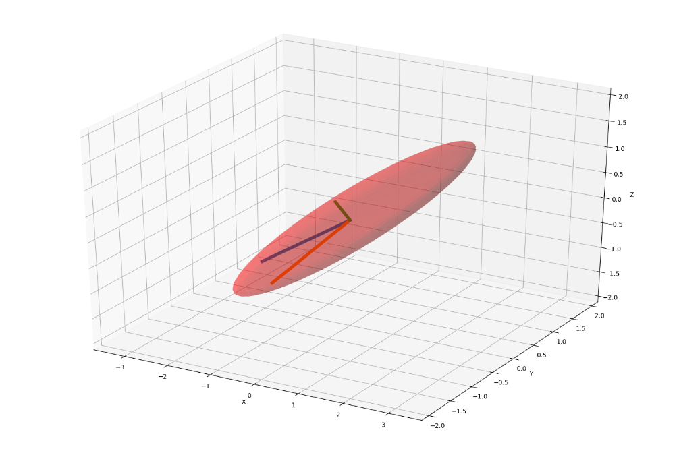

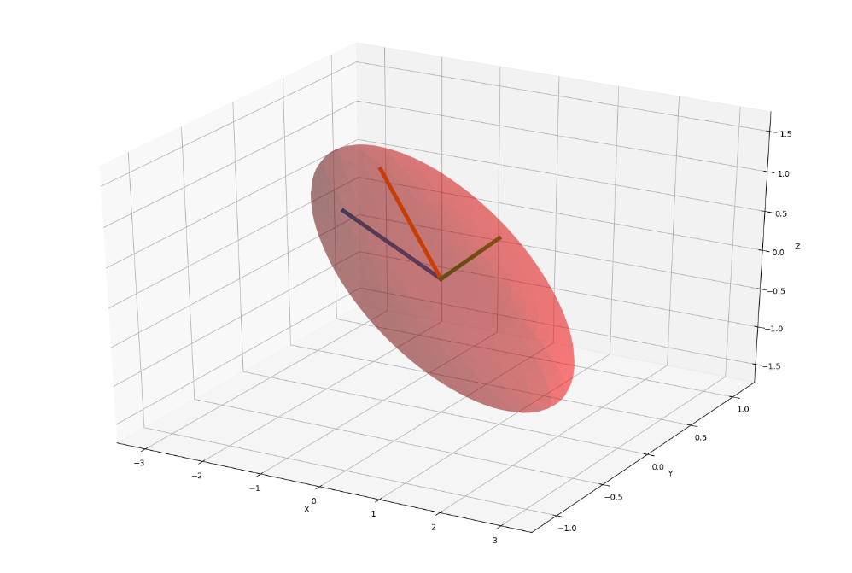

4. Macierz o stosunku wartości osobliwych powyżej 100

def find_100_proportion():  
 A = [[1 for _ in range(3)] for _ in range(3)]  
 S = [1] * 3  
 while S[0] < 100 * S[2]:  
 for i in range(3):  
 for j in range(3):  
 A[i][j] = random.uniform(-3, 3)  
  
 U, S, VT = np.linalg.svd(A)  
 diag_S = np.diag(S)  
 print(A)  
 print(diag_S)  
 return A  
  
  
def draw_100_proportion_elipse():  
 A = find_100_proportion()  
 x, y, z = make_X_Y_Z_elipse(A)  
 draw_3d(x, y, z, 10, 90)  
 draw_3d(x, y, z, 20, 40)  
 draw_3d(x, y, z, 50, 80)  
 draw_3d(x, y, z, 60, 40)  
 draw_3d(x, y, z, 100, 100)

Macierz A







Macierz diagonalna

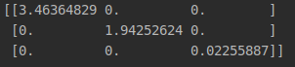

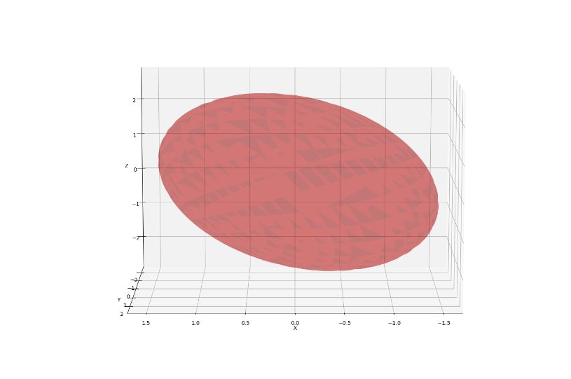

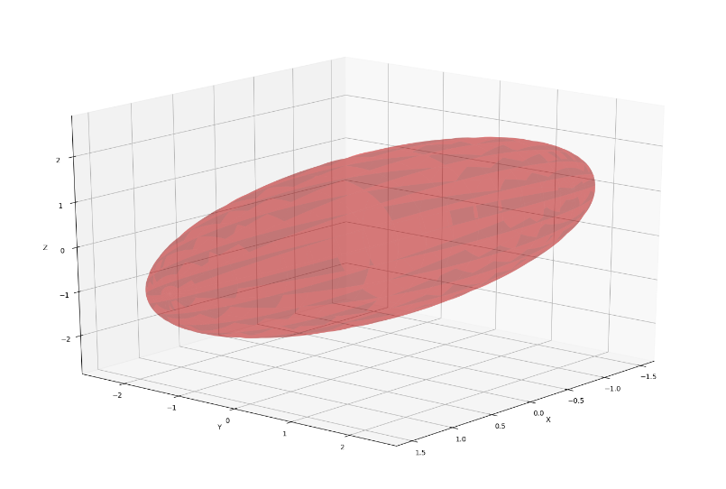

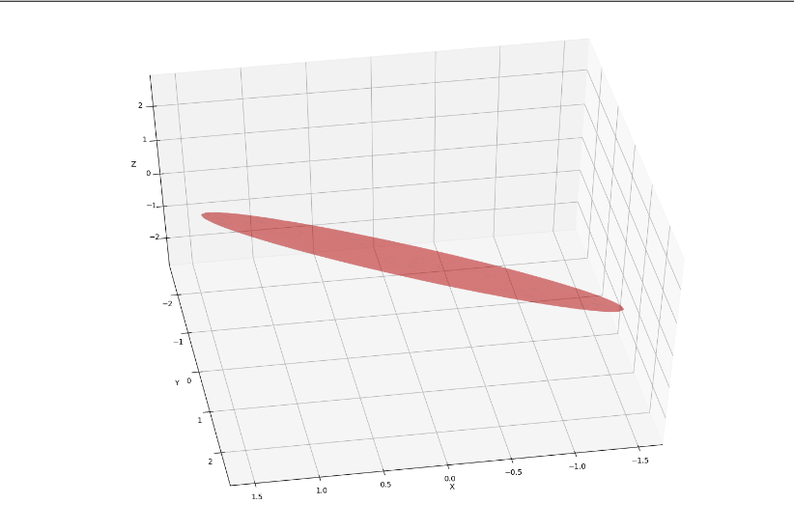

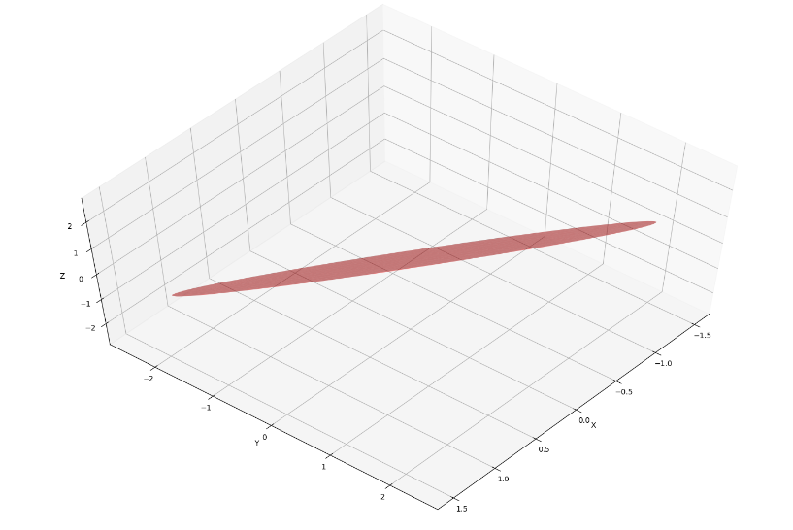

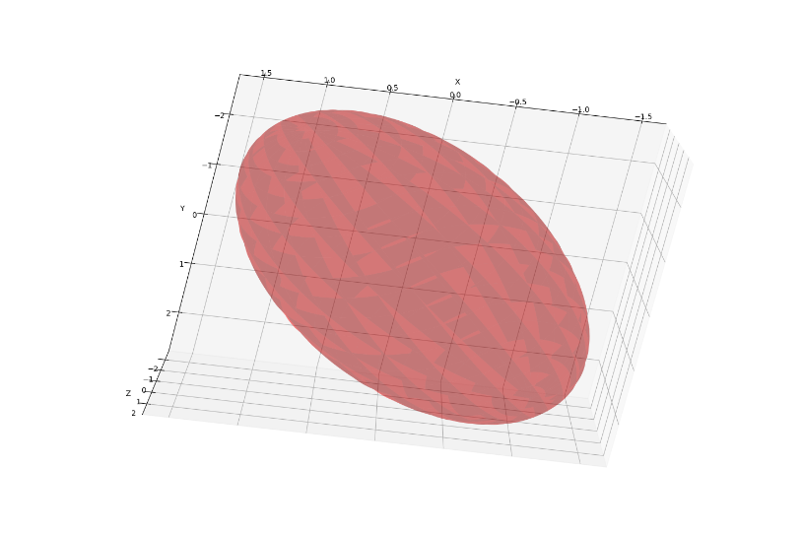

5) Wizualizacje poszczególnych transformacji

def show_transformation():  
 A1, A2, A3 =transform_vectors()  
 U, S, VT = np.linalg.svd(A2)  
 diag_S = np.diag(S)  
 draw_elipse_with_singular_values(VT)  
 draw_elipse_with_singular_values(diag_S @ VT)  
 draw_elipse_with_singular_values(U @ diag_S @ VT)

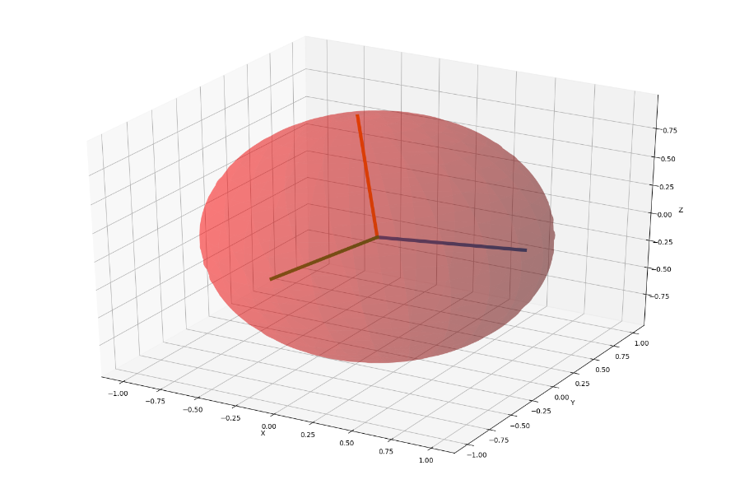

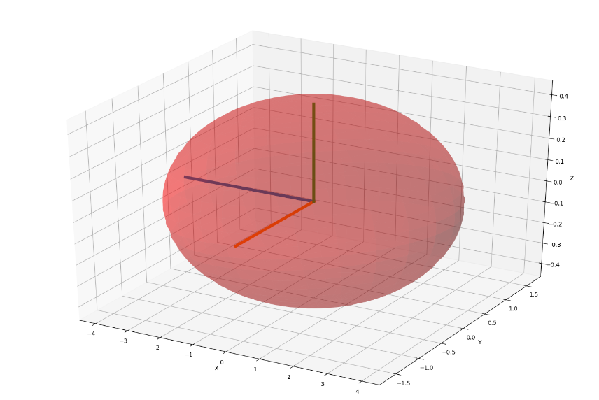

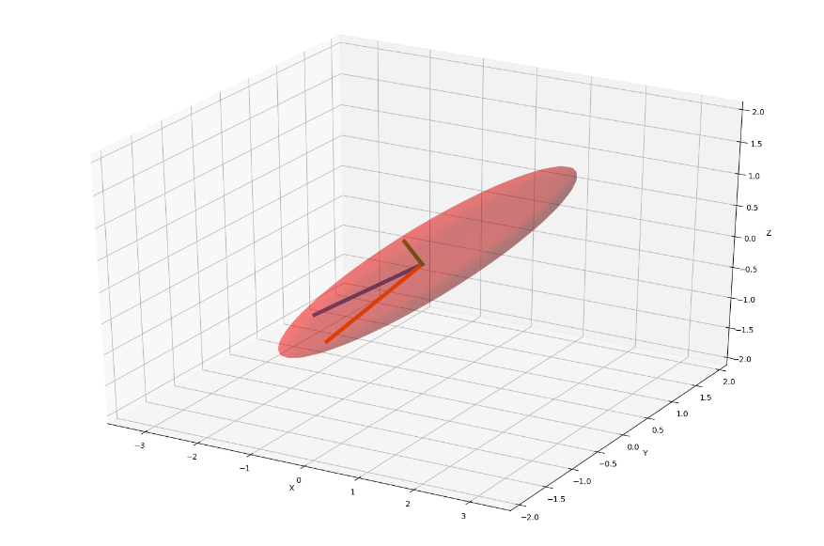

6)Kompresja obrazu

def lena_compression(k):  
 path, extension = os.path.splitext("lena.png")  
 img = Image.open("lena.png")  
 width = img.width  
 height = img.height  
 img_arr = np.array(img)  
  
 arr1 = img_arr.transpose(0, 2, 1).reshape(height * 3, width)  
 arr2 = img_arr.transpose(1, 2, 0).reshape(width * 3, height)  
   
 U, S, A1 = linalg.svd(arr1)  
 U, S, A2 = linalg.svd(arr2)  
  
 B1 = A1[:k*3, :]  
 B2 = A2[:k*3, :]  
  
 C1 = B1.T.dot(B1)  
 C2 = B2.T.dot(B2)  
  
 arr2 = np.tensordot(img_arr, C1, (1, 0))  
 arr3 = np.tensordot(arr2, C2, (0, 0))  
 arr4 = arr3.transpose(2, 1, 0)  
  
 imgk = Image.fromarray(np.uint8(arr4))  
 file = path + str(k) + extension  
 imgk.save(file)  
  
def compress_lena_arr():  
 arr = [1, 3, 5, 10, 15, 50, 100, 200]  
 for ele in arr:  
 lena_compression(ele)

k = 1

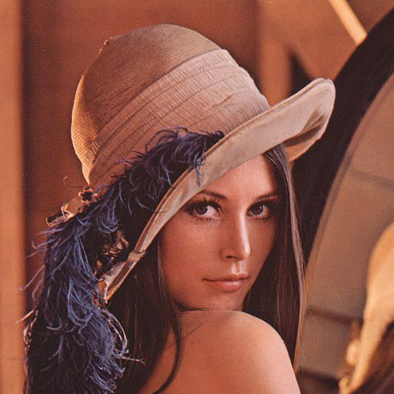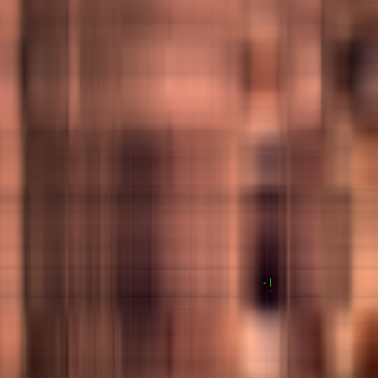

K = 3

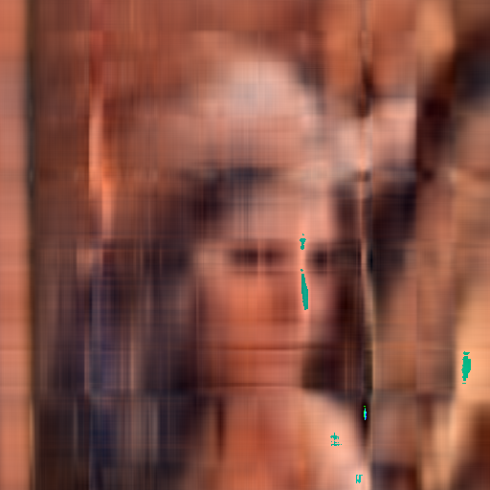

K = 5

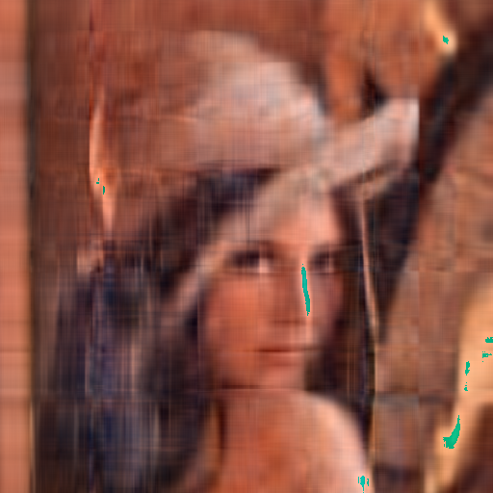

K = 10

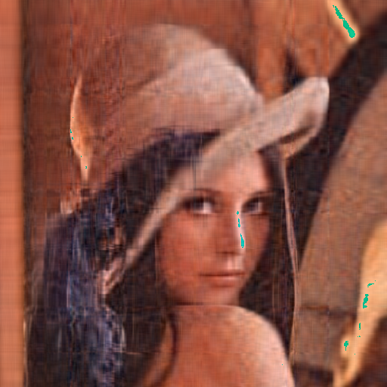

K = 15

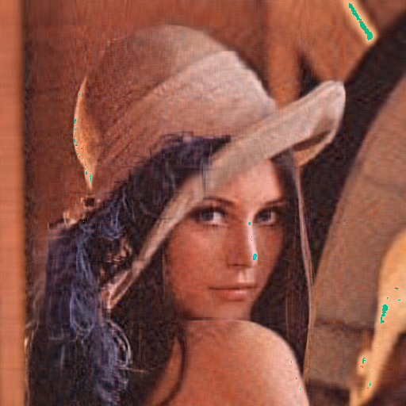

K = 50

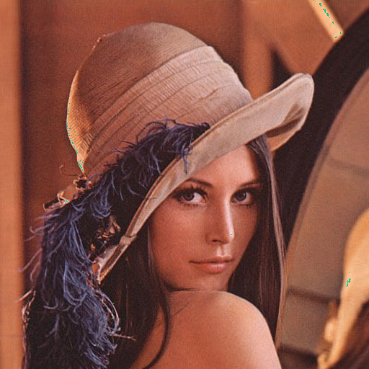

K = 100

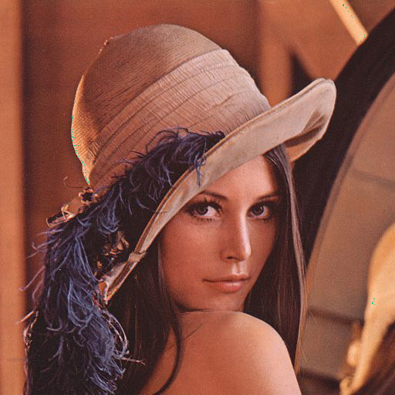

K = 200

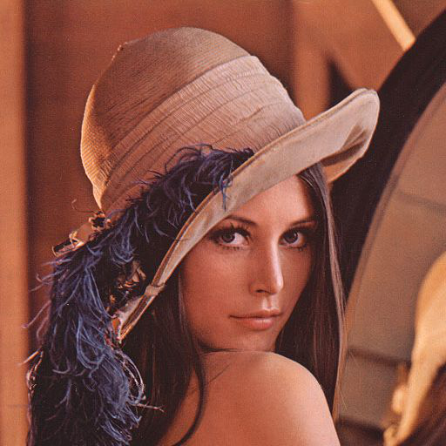

Wnioski kompresja obrazu przy pomocy SVD jest bardzo opłacalna. Przy k równym około 50, 100 bardzo ciężko jest zauważyć jakiekolwiek różnice pomiędzy obrazem skompresowanym, a obrazem oryginalnym.